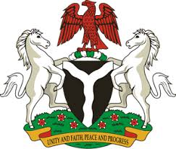

Please check against delivery
HUMAN RIGHTS COUNCIL
38TH SESSION OF THE WORKING GROUP OF THE UPR
REVIEW OF SINGAPORE
12TH MAY, 2021
STATEMENT BY NIGERIA
Madam President,
Nigeria welcomes the delegation of the Republic of Singapore, and thanks it for the presentation of the country’s Third Cycle UPR National Report. We applaud the Government of Singapore for the progress achieved in the promotion and protection of the rights of women and girls, persons with disabilities, as well as older persons.
2. In the spirit of constructive dialogue, Nigeria makes the following recommendations to Singapore:
- Strengthen measures to combat human trafficking, and ensure the protection of the rights of victims, as well as the rights of migrants; and
- Adopt further measures to ensure access to justice, as well as the enjoyment of human rights by all without discrimination.
3. We wish Singapore a very successful review process.
I thank you.
******

