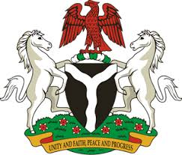
Please check against delivery
HUMAN RIGHTS COUNCIL
38TH SESSION OF THE WORKING GROUP OF THE UPR
REVIEW OF SIERRA LEONE
12TH MAY, 2021
STATEMENT BY NIGERIA
Madam Vice President,
Nigeria warmly welcomes the delegation of the Republic of Sierra Leone, and thanks it for the presentation of the country’s National Report for the Third Cycle UPR, as well as the update provided today. We commend the Government of Sierra Leone for its commitment to the UPR process, and its efforts in implementing previous recommendations.
2. Nigeria takes positive note of the Government’s efforts in tackling sexual and gender-based violence, as well as women empowerment. The Government’s efforts in the field of administration of justice, access to justice and the rule of law are also commendable. We also note with encouragement Sierra Leone’s efforts in tackling corruption and addressing the country’s education and health challenges.
3. In the spirit of constructive dialogue, and acknowledging the Government’s efforts in the field of human rights, Nigeria recommends the following to Sierra Leone:
- Adopt further measures in combatting sexual and gender-based violence, access to justice and women empowerment, as well as poverty reduction;
- Strengthen measures to ensure the improvement of the socio-economic wellbeing of the people, and seek necessary support to enhance its capacity for the promotion and protection of human rights and fundamental freedoms.
4. To conclude, we wish Sierra Leone a very successful review process.
I thank you.
******

