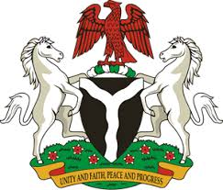
Please check against delivery
HUMAN RIGHTS COUNCIL
38TH SESSION OF THE WORKING GROUP OF THE UPR
REVIEW OF SEYCHELLES
10TH MAY, 2021
STATEMENT BY NIGERIA
Madam Vice President,
Nigeria welcomes the delegation of Seychelles, and thanks it for the presentation of the country’s National Report for the Third Cycle UPR. We commend the Government of Seychelles for the concerted efforts in the implementation of previous recommendations, as well as its continued cooperation and commitment to the UPR process.
2. Nigeria notes with encouragement efforts by the Government of Seychelles at strengthening the country’s legal and institutional frameworks for the promotion and protection of human rights. We applaud the Government’s efforts in the fields of health, education and efforts at addressing the negative effect of climate changes, as well as combating human trafficking and the protection of the rights of persons with disabilities.
3. In the spirit of constructive dialogue and acknowledging the progress achieved in upholding human rights, Nigeria makes the following recommendations to Seychelles:
- Strengthen measures for the fight against corruption, money laundering, and human trafficking;
- Continue efforts in ensuring access to quality education and health care services, as well as efforts in addressing the negative effect of climate change;
- Scale up efforts in the promotion and protection of human rights, especially the rights of persons in vulnerable situations.
4. To conclude, we wish Seychelles a very successful review process.
I thank you.
******

