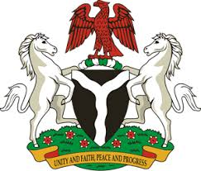
Please check against delivery
HUMAN RIGHTS COUNCIL
38TH SESSION OF THE WORKING GROUP OF THE UPR
REVIEW OF NAMIBIA
3RD MAY, 2021
STATEMENT BY NIGERIA
Madam President,
Nigeria warmly welcomes the delegation of the Republic of Namibia to the presentation of the country’s National Report for the Third Cycle UPR. We commend the Government of Namibia for its commitment to the UPR process and other human rights mechanism, as well as its efforts in the implementation of previous recommendations.
2. Nigeria takes positive note of Namibia’s efforts at strengthening the country’s legal and institutional frameworks for the promotion and protection of human rights. We also note with encouragement, the Government’s determination to combat human trafficking, and the adoption of a National Plan of Action on Gender-Based Violence (2019-2023).
3. While acknowledging efforts by Namibia in upholding human rights and in the spirit of constructive dialogue, Nigeria recommends the following to Namibia:
- Continue efforts in combatting gender-based violence, and ensuring the protection of the rights of persons in vulnerable situations; and
- Sustain efforts in combatting human trafficking, poverty reduction, as well as access to justice.
4. In conclusion, we wish Namibia a very successful review process.
I thank you.
******

