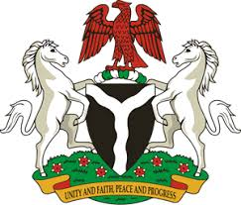
Please check against delivery
HUMAN RIGHTS COUNCIL
38TH SESSION OF THE WORKING GROUP OF THE UPR
REVIEW OF MOZAMBIQUE
4TH MAY, 2021
STATEMENT BY NIGERIA
Mr. Vice President,
Nigeria welcomes the delegation of Mozambique and thanks it for the presentation of the country’s Third Cycle UPR National Report. We take positive note of efforts by the Government of Mozambique towards the implementation of previous recommendations, and commend its commitment to the UPR process.
2. Nigeria notes with encouragement Mozambique’s continued efforts at strengthening social policies for poverty reduction, with a view to improving the socio-economic well-being of its people. The Government’s determination to combat human trafficking and corruption, as well as ensuring the protection of the rights of persons in vulnerable situation, especially persons with albinism, are also commendable.
3. In the spirit of constructive dialogue, Nigeria makes the following recommendations to Mozambique:
- Strengthen measures to combat human trafficking, ensure the protection of the rights of women and children, and all persons in vulnerable situations; and
- Sustain efforts in upholding human rights and seek necessary support to enhance its capacity in this regard.
4. In conclusion, we wish Mozambique a very successful review process.
I thank you.
******

