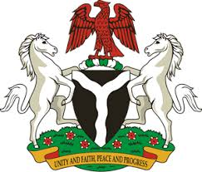
Please check against delivery
HUMAN RIGHTS COUNCIL
38TH SESSION OF THE WORKING GROUP OF THE UPR
REVIEW OF ESTONIA
4TH MAY, 2021

STATEMENT BY NIGERIA
Madam President,
Nigeria welcomes the delegation of the Republic of Estonia to the presentation of the country’s National Report for the Third Cycle UPR, and thanks it for the update provided today. We commend the Government of Estonia for its cooperation and commitment to the UPR process and other human rights mechanisms.
2. Nigeria applauds the Government of Estonia for its efforts in combatting human trafficking and labour exploitation, and protecting the rights of victims. We take positive note of Estonia’s efforts in combating discriminations, as well as tackling the menace of hate crimes.
3. In the spirit of constructive dialogue, Nigeria makes the following recommendations to Estonia:
- Scale up efforts in combatting discriminations and hate crimes; and
- Adopt further measures in combatting human trafficking, and protecting the rights of victims, as well as the rights of migrants.
4. In conclusion, we wish Estonia a very successful review process.
I thank you.
******

