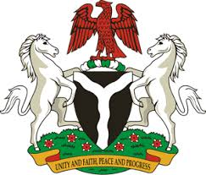
Please check against delivery
HUMAN RIGHTS COUNCIL
38TH SESSION OF THE WORKING GROUP OF THE UPR
REVIEW OF DENMARK
6TH MAY, 2021
STATEMENT BY NIGERIA
Madam President,
Nigeria welcomes the delegation of the Kingdom of Denmark to the presentation of the country’s Third Cycle UPR National Report, and thanks it for the update provided today. We commend the Government of Denmark for its effort in the implementation of previous recommendations, and its continued cooperation and commitment to the UPR mechanism.
2. Nigeria notes with encouragement, Denmark’s efforts in combatting racism and racial discrimination, hate speech and hate crimes, as well as measures adopted to ensure non-discrimination. We also commend the Government’s efforts in combatting human trafficking and ensuring the protection of the rights of victims.
3. In the spirit of constructive dialogue, Nigeria makes the following recommendations to Denmark:
- Further strengthen measures to combat racism and racial discrimination, hate speech and hate crimes, and ensure the full enjoyment of human rights by all; and
- Sustain efforts in combatting human trafficking and ensure the protection of the rights of victims, as well as the rights of migrants.
4. In conclusion, we wish Denmark a very successful review process.
I thank you.
******

