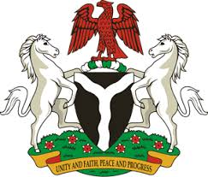
Please check against delivery
HUMAN RIGHTS COUNCIL
38TH SESSION OF THE WORKING GROUP OF THE UPR
REVIEW OF BELGIUM
5TH MAY, 2021
STATEMENT BY NIGERIA
Madam President,
Nigeria welcomes the delegation of the Kingdom of Belgium, and thanks it for the presentation of its National Report for the Third Cycle of the UPR. We commend the Government of Belgium for its continued cooperation and engagement with the UPR process and other human rights mechanisms.
2. Nigeria takes positive note of Belgium’s efforts in combatting racism, racial discrimination and xenophobia and related intolerance. We also commend the Government’s efforts in combatting human trafficking and the protection of the rights victims, the rights of migrants, and persons in vulnerable situations.
3. In the spirit of constructive dialogue, Nigeria makes the following recommendations to Belgium:
- Strengthen efforts to combat racism, racial discrimination, xenophobia and related intolerance, in order to ensure the full enjoyment of human rights by all; and
- Adopt further measures in combatting human trafficking and ensure the protection of the rights of victims, as well as the rights of migrants.
4. Finally, we wish Belgium every success in its review process.
I thank you.
******

