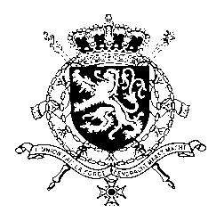
Représentation permanente de la Belgique auprès des Nations Unies et auprès des institutions spécialisées à Genève

WG UPR 38 – Sierra Leone
Belgian Intervention
12 May 2021

Madam President,

Belgium welcomes the progress made by the government of Sierra Leone, in particular the decriminalisation of defamation and the lifting of the ban on pregnant girls attending school. Still, there is room for progress. Belgium therefore recommends Sierra Leone to

R1. To harmonize laws to prevent and eliminate child marriage and undertake comprehensive awareness-raising campaigns on the negative consequences of child marriage on girls.

R2. Ratify the Second Optional Protocol to the International Covenant on Civil and Political Rights, aiming at the abolition of the death penalty

R3. Ratify the Optional Protocol to the Convention on the elimination of all forms of discrimination against women.

Thank you, Madam President.

