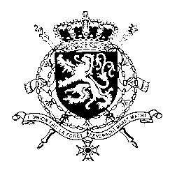
Représentation permanente de la Belgique auprès des Nations Unies et auprès des institutions spécialisées à Genève

WG UPR – Paraguay
Belgian intervention
5 May 2021

Madam President,

Belgium welcomes the adoption by Paraguay of a National Action Plan for the Protection of Children from all forms of violence. However, we are concerned about the increase in sexual violence against adolescent girls and the prevalence of child labour. Therefore, Belgium recommends Paraguay to:

R1. Step up its efforts against child labour and adopt regulatory instruments and policies for eliminating the practice of criadazgo, including support for the family of origin and the development of awareness-raising campaigns;

Regarding discrimination and violence against human rights defenders and journalists, we recommend Paraguay to:

R2. Adopt a comprehensive legislation prohibiting discrimination, including discrimination based on sexual orientation and gender identity.

R3. Ensure the provision of effective assistance and protection to human rights defenders and journalists against threats, violence and intimidation, and investigate attacks, reprisals and assaults against them.

Thank you, Madam President.

