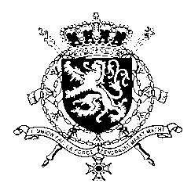
Représentation permanente de la Belgique auprès des Nations Unies et auprès des institutions spécialisées à Genève

WG UPR 38 – Denmark
Belgian intervention
6th of May 2021

Madam President,

Belgium welcomes the progress made by Denmark since its previous UPR. Notwithstanding these achievements, there is still room for progress, in particular in the field of discrimination and racism.

Belgium therefore recommends the government of Denmark to:

R1. Step up efforts to increase women’s representation in politics and in companies;

R2. Adopt a national action plan against racism, racial discrimination, xenophobia and related intolerance;

R3. Take the necessary measures to prevent statelessness, in line with national law and the 1961 Convention on the Reduction of Statelessness, specifically regarding children born in Denmark.

Thank you, Madam President.

