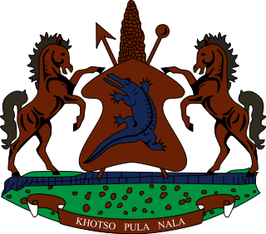

STATEMENT BY THE KINGDOM OF LESOTHO DURING THE 3rd UPR REVIEW OF SIERRA LEONE

12 MAY, 2021

Thank you, Madam President,
My delegation welcomes the delegation of Sierra Leone to the Working Group. We applaud Sierra Leone for mainstreaming the educational system and promoting the right to education of girls, by lifting the 2015 ban on pregnant girls in schools. We further note rigorous steps taken to end gender based violence, such as the amendment of the Sexual Offences Act and the setting up of the Sexual Offences Model Court in July 2020.

Irrespective of the notable progress made, we wish to make the following two recommendations for consideration by the delegation of Sierra Leone: 1. To Strengthen cooperation with special mechanisms of OHCHR by extending standing invitations to all special procedures; and 2. To continue efforts to fight child trafficking, including undertaking awareness campaigns and providing regular training to the security forces at border areas.
I wish Sierra Leone every success with this UPR cycle.
I thank you

