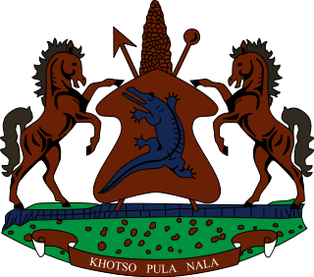

STATEMENT BY THE KINGDOM OF LESOTHO DURING THE 3rd UPR REVIEW OF NIGER

03 MAY, 2021

Thank you, Madam President,
My delegation welcomes the delegation of Niger to the Working Group. We comment Niger for efforts made to combat torture by adopting Act No. 2020/05 of 11 May 2020, on the criminalization of torture. We further note the steps taken to address all forms of slavery, by implementing the National Plan of Action to Combat Slavery and Similar Practices of 2019-2021, with a view to reducing the traditional practice of slavery among certain ethnic groups in the country.

Whilst Niger has made a remarkable progress in promoting the human rights of its people, we wish to make the following two recommendations for their consideration: 1. To continue efforts to eliminate inequalities between men and women in all spheres of life, including in the area of customary inheritance law; and 2. To beef up measures to fight early child marriage and female genital mutilation which continue to best the country.

We wish Niger every success with this UPR cycle.

I thank you Madam President.

