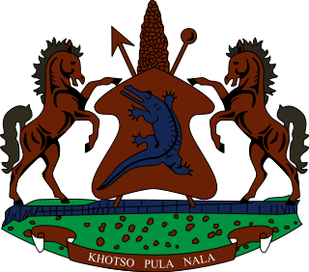

STATEMENT BY THE KINGDOM OF LESOTHO DURING THE 3rd UPR REVIEW OF MOZAMBIQUE

04 MAY, 2021

Thank you Madam President,

Lesotho welcomes the delegation of Mozambique to the Working Group. We take note of the steps which Mozambique has taken in various areas to promote and protect human rights in the country. We applaud Mozambique for safeguarding the freedom of opinion and expression by establishing the Media Higher Council, a body of discipline and consultation, which ensures access to information, freedom of the press, as well as the rights of airtime and response.

Despite the efforts made, we wish to make the following two recommendations for consideration by the delegation of Mozambique: I. To ratify the International Covenant on Economic, Social and Cultural Rights and the Convention for the Protection of All Persons from Enforced Disappearances; and 2. To continue efforts to include human rights education in the curricula of the National Education System at the basic and secondary level.
We wish Mozambique every success with this UPR cycle.
I thank you Madam President.

