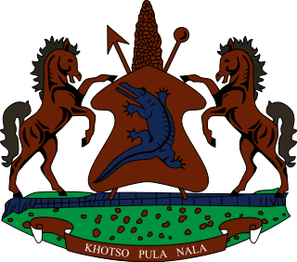

**STATEMENT BY THE KINGDOM OF LESOTHO DURING THE 3rd UPR REVIEW OF NAMIBIA**

**03 MAY, 2021**

**Thank you, Madam President,**

Lesotho extends a warm welcome to the delegation of Namibia to the Working Group and thank them for the presentation of their National Report. We applaud Namibia for ratifying the Optional Protocol to the Convention on the Rights of the Child (CRC) and for enacting the Basic Education Act of 2020, whose objective is to ensure equitable inclusive quality education and to promote and protect the right of learners to education.

In the spirit of cooperation and constructive approach, which forms the premise of this process, we wish to make the following two recommendations for consideration by the delegation of Namibia: 1. To undertake measures to address gender based violence, especially against persons with disabilities; and 2. Strengthen cooperation with international human rights protection mechanisms, such as the UN special procedures mandate holders.

We wish Namibia every success with this UPR cycle.

**I thank you Madam President.**