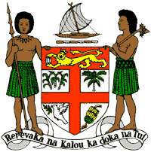
PERMANENT MISSION OF THE REPUBLIC OF FIJI TO THE UNITED NATIONS
OFFICE AND OTHER INTERNATIONAL ORGANISATIONS AT GENEVA
38TH SESSION OF THE UPR WORKING GROUP
SOMALIA

Fiji commends Somalia for ratifying the International Convention on the Rights of Persons with Disabilities and establishing the National Disability Agency, and for its recommitment to the National Action Plan to End Sexual Violence in Conflict.
Fiji offers the following recommendations:
- Ensure that women, children, persons with disabilities, minority groups, and local communities are meaningfully engaged in the development and implementation of climate change and disaster risk reduction frameworks.
- Consider establishing a moratorium on the death penalty, with a view to further consider its complete abolition.
- Consider progressive law reforms on media freedom and freedom of expression, further guaranteeing the protection and empowerment of journalists and human rights defenders.

