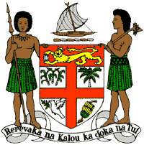
PERMANENT MISSION OF THE REPUBLIC OF FIJI TO THE UNITED NATIONS
OFFICE AND OTHER INTERNATIONAL ORGANISATIONS AT GENEVA
38TH SESSION OF THE UPR WORKING GROUP
SOLOMON ISLANDS

Fiji welcomes the delegation of the Solomon Islands and congratulates Solomon Islands for the achievements in the implementation of the recommendations from its previous cycle. Fiji commends the Solomon Islands on combatting human trafficking, including creating criminal liability for internal trafficking in persons.
Fiji offers the following recommendations:
- Ensure that women, children, persons with disabilities, minority groups, and rural communities are meaningfully engaged in the development and implementation of climate change and disaster risk reduction frameworks.
- Continue efforts to combat climate change, including considering the development and implementation of relocation strategies for coastal communities affected by rising sea levels.
- Continue and intensify nationwide awareness-raising programmes on human rights and the enjoyment of human rights, including programmes specifically targeting women, youth, and children.
- Consider progressive anti-discrimination law reforms to guarantee comprehensive protection against discrimination in accordance with international human rights law, norms, and standards.
- Continue efforts to combat and eliminate violence against women and children and consider the development and adoption of a national strategy to frame and advance these efforts.

