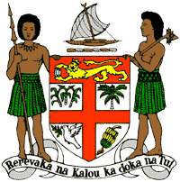
PERMANENT MISSION OF THE REPUBLIC OF FIJI TO THE UNITED NATIONS
OFFICE AND OTHER INTERNATIONAL ORGANISATIONS AT GENEVA
38TH SESSION OF THE UPR WORKING GROUP
SIERRA LEONE

Fiji commends Sierra Leone for the abolition of its criminal libel laws and the lifting of the ban on pregnant girls in school.
Fiji offers the following recommendations:
- Ensure that women, children, persons with disabilities, minority groups, and local communities are meaningfully engaged in the development and implementation of climate change and disaster risk reduction frameworks.

- Continue to make education a priority by addressing obstacles to school attendance and completion, and ensuring that pregnant girls return to school.

- Intensify efforts to fully eliminate female genital mutilation through progressive law reforms that prohibit the practice in all its forms and awareness-raising campaigns on the harmful effects of the practice on girls, women and wider society.

