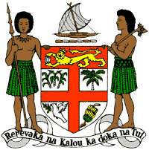
PERMANENT MISSION OF THE REPUBLIC OF FIJI TO THE UNITED NATIONS
OFFICE AND OTHER INTERNATIONAL ORGANISATIONS AT GENEVA
38TH SESSION OF THE UPR WORKING GROUP
SEYCHELLES

Fiji welcomes the delegation of Seychelles and commends Seychelles on the passage of the Domestic Violence Act.
Fiji offers the following recommendations:
- Ensure that women, children, persons with disabilities, minority groups, and local communities are meaningfully engaged in the development and implementation of climate change and disaster risk reduction frameworks.

- Continue to implement and operationalise the Domestic Violence Act, ensuring that support services for survivors are adequately resourced to carry our their functions.

- Continue to implement the Prohibition of Trafficking in Persons Act, with emphasis on the importance of promptly investigating and prosecuting cases of child trafficking.

- Ensure to thoroughly investigate and promptly prosecute cases of using, procuring or offering children for prostitution.

