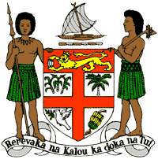
PERMANENT MISSION OF THE REPUBLIC OF FIJI TO THE UNITED NATIONS
OFFICE AND OTHER INTERNATIONAL ORGANISATIONS AT GENEVA
38TH SESSION OF THE UPR WORKING GROUP
PALAU

Fiji welcomes the delegation of Palau and congratulates the delegation for the achievements in the implementation of the recommendations from its previous cycle. Fiji congratulates Palau on the steps it has taken to combat climate change, including passing the Energy Act and submitting the Intended Nationally Determined Contribution under the Paris Agreement to work towards the objectives of the UNFCCC.
Fiji offers the following recommendations:
- Ensure that women, children, persons with disabilities, minority groups, and rural communities are meaningfully engaged in the development and implementation of climate change and disaster risk reduction frameworks.
- Continue efforts to combat climate change, including considering the development and implementation of relocation strategies for coastal communities affected by rising sea levels.
- Continue and intensify nationwide awareness-raising programmes on human rights and the enjoyment of human rights, including programmes specifically targeting women, youth, and children.
- Consider progressive anti-discrimination law reforms to guarantee comprehensive protection against discrimination in accordance with international human rights law, norms, and standards.
- Continue efforts to combat and eliminate violence against women and children and consider the development and adoption of a national strategy to frame and advance these efforts.

