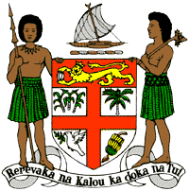
PERMANENT MISSION OF THE REPUBLIC OF FIJI TO THE UNITED NATIONS
OFFICE AND OTHER INTERNATIONAL ORGANISATIONS AT GENEVA
38TH SESSION OF THE UPR WORKING GROUP
NAMIBIA

Fiji commends Namibia for its strides in reducing the prevalence of HIV-AIDS and combatting human trafficking.

Fiji offers the following recommendations:

- Continue to explore progressive law and policy reforms to address cross-sectoral environmental challenges, including climate change adaptation and mitigation frameworks.

- Ensure that women, children, persons with disabilities, minority groups, and local communities are meaningfully engaged in the development and implementation of climate change and disaster risk reduction frameworks.

- Strengthen initiatives aimed at preventing torture, including the workshop trainings on the “Prevention of Torture Training Manual for Police Officers” and the Prevention of Torture Project.

- Continue and intensify efforts to enrol indigenous and rural children through the mobile school unit programme.

