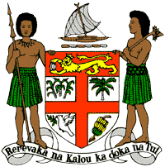
PERMANENT MISSION OF THE REPUBLIC OF FIJI TO THE UNITED NATIONS
OFFICE AND OTHER INTERNATIONAL ORGANISATIONS AT GENEVA
38TH SESSION OF THE UPR WORKING GROUP
DENMARK

Fiji commends Denmark’s strides in protecting the rights of persons with disabilities and its 2020 climate law requiring a 70% reduction of CO2- emissions in 2030 compared to 1990.
Fiji offers the following recommendations:
- Ensure the meaningful participation of women, children, persons with disabilities, and Inuit communities in the development and implementation of climate change and disaster risk reduction frameworks.
- Explore the possibility of withdrawing its reservation to article 40(2)(b)(v) of the Convention on the Rights of the Child.
- Continue to encourage and ensure that businesses domiciled in its jurisdiction respect human rights and are environmentally responsible and accountable.

