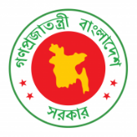
38th Session of UPR Working Group
Statement by Bangladesh on Namibia under 3rd Cycle of UPR
03 May 2021, 09:00-12:30 hrs.
Thank you, Madam President.
02. Bangladesh warmly welcomes the distinguished delegation of Namibia in the 3rd cycle of UPR.
03. We appreciate Namibia’s efforts to maintain peace and stability as a priority.
04. Bangladesh recommends Namibia to:
One, continue to invest in education and take further measures to reduce school drop-out rate and achieve gender parity in primary and secondary education.
Two, step up efforts to reduce maternal and child mortality rate through the improvement of health care services.
Three, seek technical assistance and cooperation from the international community to continue to fight HIV/AIDS.
05. We wish Namibia a successful review.
I thank you.
***

