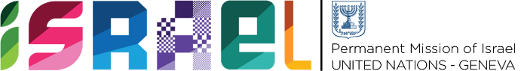 | Check against delivery  1 minutes 15 secs

Statement on behalf of the State of Israel
UPR WORKING GROUP-
38th Session
May 2021

Review of Latvia

Israel warmly welcomes the delegation from Latvia and thanks it for its National Report.
We would like to commend Latvia for its progress regarding women’s rights, including the approval of Latvia’s first National Action Plan on the Implementation of UN Security Council Resolution 1325 and the considerable increase of women participation in Latvia’s political processes. Israel would also like to congratulate the Latvian National Armed Forces for being one of the leading NATO armed forces in terms of women’s representation.
We would also like to commend Latvia for hosting the 2018 Baltic Pride, which resulted in a record number of participants, and for the recent abolishment of the rule that a same-sex partner must pay higher state fees to inherit the estate of their deceased partner.
Israel would like to recommend the following:
- To recognize same-sex civil unions as a further step in the fight against discrimination of LGBTQI persons.
- To continue to work towards adopting the Prostitution Limitation Law as soon as possible.
Israel would also like to repeat its recommendation from Latvia's last UPR:
- To continue to develop policies to ensure the full enjoyment of rights of persons with disabilities, particularly in terms of inclusive education and accessibility.
Thank you.

