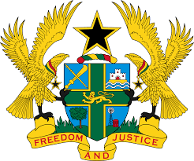

STATEMENT BY GHANA DELIVERED BY H.E RAMSES JOSEPH CLELAND, AMBASSADOR AND PERMANENT REPRESENTATIVE, WEDNESDAY, 12TH MAY 2021

REVIEW OF SINGAPORE

Thank you, Madam President.

Ghana welcomes the delegation of Singapore to the UPR Working Group and we thank them for the presentation of their national report.
2. We commend Singapore for the impressive efforts at building a fair and inclusive society by the provision of universal health care, enhancing the protection of women and children as well as adoption of legislation to strengthen the protection of youth against sexual exploitation.
3. Ghana makes the following recommendations:
- To ratify OPCAT, the International Covenant on Civil and Political Rights and its Optional Protocols;
- Ensure that all cases of sexual and labour exploitation, sale, abduction and trafficking are investigated and the perpetrators brought to justice.
Ghana wishes Singapore a successful review outcome.

I thank you.

