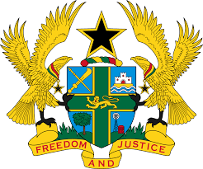

STATEMENT BY GHANA DELIVERED BY H.E RAMSES JOSEPH CLELAND,
AMBASSADOR AND PERMANENT REPRESENTATIVE,
WEDNESDAY 12TH MAY 2021

REVIEW OF SIERRA LEONE

Thank you, Madman President.
Ghana welcomes the delegation of Sierra Leone to the UPR Working Group and
we thank them for their report.
2. My delegation acknowledges the establishment of the Independent Police Compliant Board, implementation of the National Anti-Corruption Strategy (2019-2023) as well as the launch of the Poverty Reduction Strategy Paper aimed at improving free quality education.
3. We further commend the government for the adoption of the policy of “radical inclusion and comprehensive safety” to promote universal education for all children without discrimination against pregnant girls.
4. Ghana has the following recommendations:
- Continue to reinforce relevant measures to ensure the elimination of violence against women, including prohibition of all harmful practice such as Female Genital Mutilation ;
- Consider ratifying outstanding International instruments, of note are the Optional Protocol to CEDAW and the Optional Protocol to the Convention against Torture and Other Cruel, Inhuman or Degrading Treatment or Punishment (OP-CAT) and;
- Ensures full respect for the right to freedom of expression by preventing and ending harassment of journalists.
Ghana wishes Sierra Leone a successful review outcome.

I thank you.

