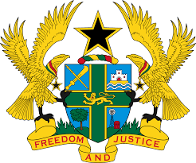

STATEMENT BY GHANA DELIVERED BY H.E RAMSES JOSEPH CLELAND, AMBASSADOR AND PERMANENT REPRESENTATIVE,
FRIDAY 7TH MAY, 2021

REVIEW OF SOMALIA

Thank you, Madam President.
Ghana extends a warm welcome to the delegation of Somalia to the UPR Working Group and thank them for the comprehensive report.
We commend Somalia for important steps taken to address key human rights challenges in Somalia, such as constructive consultations among relevant stakeholders in the Somali Constitutional Review process, adoption of a number of legislations, including the Somalia Political Parties Law and the Independent Human Rights Commission Law.
We further note the development of the National Reconciliation Framework (NRF) in 2019 and the Somalia Recovery and Resilience Framework (RRF), which supports the country’s progress from drought recovery.
Ghana has the following recommendations:
- Continue its efforts to strengthen the provision of comprehensive health care, especially people of the Northern part of Somalia;
- Continue efforts to ensure the ratification of outstanding International treaties and protocols, including the Optional Protocol to the Convention Against Torture (OP-CAT) and Convention on the Elimination of All Forms of Discrimination against Women and finally;
- To continue ongoing efforts to protect the rights to freedom of expression and media, in compliance with international human rights standards.
We wish Somalia a successful review outcome.

I thank you.

