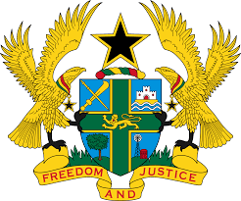

STATEMENT BY GHANA DELIVERED BY H.E RAMSES JOSEPH CLELAND, AMBASSADOR AND PERMANENT REPRESENTATIVE, THURSDAY, 6TH MAY 2021

REVIEW OF DENMARK

Thank you, Madam President.

Ghana welcomes the delegation of Denmark to the UPR Working Group and we thank them for the presentation of their national report.
2. We welcome the measures taken by the Government since their last UPR and commend Denmark the establishment of the National Unit for the prevention of domestic violence as well as a comprehensive welfare system to promote and ensure gender equality and measures by the Police to combat racism.
3. We note with concern reports from UN bodies citing concerns regarding cases of human trafficking, including sexual exploitation, as well as the resurgence of racist and xenophobic discourse.
4. Ghana makes the following three recommendations:
- To ratify the International Convention on the Protection of the Rights of All Migrant Workers and Members of Their Families;
- To intensify its efforts to combat discrimination, xenophobia as well as racism and bring the perpetrators to justice and lastly;
- To continue its efforts to strengthen measures and strategies to improve detention procedures and living conditions in migration detention centers.
Ghana wishes Denmark a successful review outcome

I thank you.

