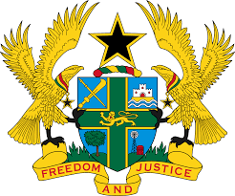

STATEMENT BY GHANA DELIVERED BY H.E RAMSES JOSEPH CLELAND, AMBASSADOR AND PERMANENT REPRESENTATIVE,
WEDNESDAY, 5TH MAY 2021

REVIEW OF BELGIUM

Thank you, Madam President.

Ghana welcomes the delegation of Belgium to the UPR Working Group.

We welcome the steps taken by the Government since their last UPR to promote and protect human rights in the country, including the establishment of a National Plan of Action on Business and Human Rights, an external independent mechanism for the oversight of the police services as well as the implementation of the third Federal Anti-Poverty Plan (2016–2019).

Nevertheless, my delegation remains concerned about reports of Police violence against refugees and migrants and call upon the Government to intensify measures to combat this violation.

We make the following three recommendations:

- Continue its efforts to promptly accede to the UN Optional Protocol to the Convention against Torture and other Cruel, Inhuman or Degrading Treatment or Punishment (OP-CAT);
- Intensify its efforts to combat hate crimes, investigate these cases and bring the perpetrators to justice lastly;
iii. Continue its efforts to strengthen measures and strategies to improve detention procedures, including prohibiting the practice of immigration detention of families with children.

We wish Belgium every success with the UPR process.

I thank you.

