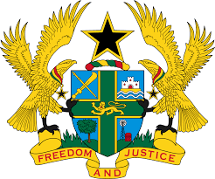

STATEMENT BY GHANA DELIVERED BY H.E RAMSES JOSEPH CLELAND, AMBASSADOR AND PERMANENT REPRESENTATIVE, TUESDAY, 4TH MAY 2021

REVIEW OF MOZAMBIQUE

Thank you, Madam President
Ghana welcomes the participation by the delegation of Mozambique to the UPR process.
We commend Mozambique for progress made since its previous UPR. This includes the reform of the Justice Administration System and prison sector, adoption of various policies and legislation to combat gender inequalities, introduction of human rights modules in the training curricula of relevant institutions and the adoption of the National Plan to Prevent and Combat Gender-Based Violence (2018-2021).
Ghana makes the following recommendations:
- Continue to reinforce relevant measures to promote and protect the rights to freedom of expression, access to information, and media freedom in the country;
- Consider ratifying outstanding International instruments, of note are the Optional Protocol to the Convention on the Rights of the Child and the Rome Statute of the International Criminal Court;
- Continue its efforts to strengthen measures to foster training and awareness of public officials, including the security forces on relevant human rights issues.
Ghana wishes Mozambique a successful review.

I thank you.

