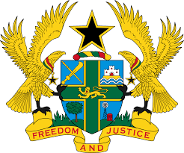

STATEMENT BY GHANA DELIVERED BY H.E. RAMSES JOSEPH CLELAND, AMBASSADOR AND PERMANENT REPRESENTATIVE, MONDAY, 3RD MAY 2021

REVIEW OF NIGER

Thank you Madam President.
Ghana warmly welcomes the delegation of Niger and thanks the delegation for their presentation.
2. We commend Niger for the acceptance of 167 recommendations out of the 168 received during the previous UPR process as well as the significant progress made in implementing these recommendations.
3. Ghana is also pleased to note the ratification of international instruments, reform of the judicial and penitentiary systems and the significant progress in the rights to health, education, food security as well as the vulnerable in society.
4. We recommend the following to Niger:
- Strengthen efforts to protect women and girls from all forms of violence and implement a strategy to eliminate negative cultural practices that are harmful and discriminate against women and girls;
- To ensures full respect for the right to freedom of expression and media freedom by preventing all harassment and unduly detention of journalists and;
- To take urgent steps to improve the conditions of detention at police stations and gendarmerie posts.
Ghana wishes Niger a successful review outcome.
I thank you.

