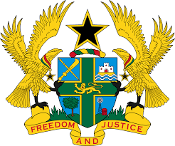

STATEMENT BY GHANA DELIVERED BY H.E. RAMSES JOSEPH CLELAND, AMBASSADOR AND PERMANENT REPRESENTATIVE, MONDAY 3RD MAY 2021

REVIEW OF NAMIBIA

Madam President, Ghana warmly welcome the delegation of Namibia to the UPR process and thank the delegation for the presentation of a comprehensive national report.
2. We welcome the creation of the Ministry of Gender Equality, Poverty Eradication and Social Welfare and the adoption of the Whistleblower Protection Act of 2017. We are also pleased to note the progress made to adopt the Prevention and Combatting Torture Bill and urge the Government to intensify its efforts in passing the bill.

3. In the spirt of constructive dialogue Ghana make the following recommendations:
- Continue enhancing the project and programmes aimed at ensuring the protection and rights of the indigenous communities;

- Intensify the efforts in fighting against HIV/AIDS, in particular, to improve access to health-care services in rural areas and;
- Intensity efforts to adopt the Optional Protocol to the Convention against Torture and Other Cruel, Inhuman or Degrading Treatment or Punishment (OP-CAT).
Ghana wishes Namibia a successful review outcome.

I thank you.

