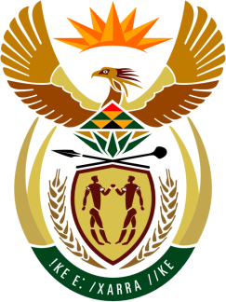

SOUTH AFRICAN PERMANENT MISSION
TO THE UNITED NATIONS
AND OTHER INTERNATIONAL ORGANISATIONS

38th SESSION OF THE WORKING GROUP ON THE
UNIVERSAL PERIODIC REVIEW

Review of sierra leone

12 may 2021

zoom

(65 Seconds)

speaker no: 97

Check against delivery

Madam President,

South Africa welcomes the distinguished delegation of Sierra Leone to this UPR Session.

South Africa wishes to respectfully make the following recommendations:

- Expedite the enactment of the Gender Equality Bill, which provides for a minimum 30% representation of women in parliament, local councils, ministries, departments and agencies.

- Harmonize laws to prevent and eliminate child marriage and undertake comprehensive awareness-raising campaigns on the negative consequences of child marriage on girls.

- Develop a National Action Plan to address Sexual and Gender Based Violence and enact a specific law to prohibit Female Genital Mutilation.

South Africa commends the Ministry of Gender and Children’s Affairs on the launch of the six pilot one-stop centres in July 2020 to provide multidisciplinary services to survivors of sexual and gender-based violence (SGBV), including psychosocial counselling, free medical services and legal assistance.
South Africa wishes Sierra Leone a successful review.

I thank you

