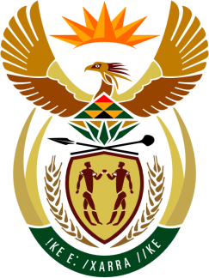

SOUTH AFRICAN PERMANENT MISSION
TO THE UNITED NATIONS
AND OTHER INTERNATIONAL ORGANISATIONS

UNIVERSAL PERIODIC REVIEW

10 MAY 2021

PALAIS DES NATIONS

Review oF SEYCHELLES

VIRTUAL (ZOOM PLATFORM)
(80 seconds)

Check against delivery
SPEAKER 43

(Vice) President,

South Africa welcomes the delegation of Seychelles led by Minister Sylvestre Radegonde, to this UPR Session.

My delegation commends Seychelles for its repeal of Section 151 of the ‘Seychelles Penal Code’, and for enacting the Seychelles ‘Human Rights Commission Act’ which is fully Paris Principles compliant.

South Africa respectfully recommends that the Seychelles government;

- takes all necessary measures to ensure that pretrial detention is reduced to the extent possible, and carried out in keeping with the provisions of the Convention against Torture and Other Cruel, Inhuman or Degrading Treatment or Punishment;

- provide sufficient resources and continue efforts to implement its inclusive education policy, ensuring that children with disabilities had the necessary support services to exercise their right to education;

- adopt a comprehensive definition of discrimination against women in its Constitution, covering internationally recognized prohibited grounds of discrimination and encompassing direct and indirect discrimination in both the public and private spheres, including intersecting forms of discrimination.

South Africa wishes Seychelles a successful review.

I thank you.

