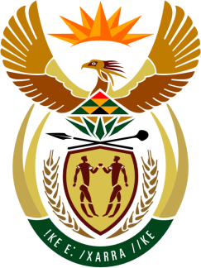

SOUTH AFRICAN PERMANENT MISSION
TO THE UNITED NATIONS
AND OTHER INTERNATIONAL ORGANISATIONS

38th SESSION OF THE WORKING GROUP ON THE
UNIVERSAL PERIODIC REVIEW

6 MAY 2021

PALAIS DES NATIONS

Review oF SOMALIA

VIRTUAL (ZOOM PLATFORM)
(65 seconds)

Check against delivery
(SPEAKER 63)

South Africa welcomes the ratification of the Convention on the Rights of Persons with Disabilities as well as the AU Convention for the Protection and Assistance of Internally Displaced Persons in Africa, and further welcomes the commitments to strengthen the protection of children affected by armed conflict and encourage its continuing efforts, in-spite of the severe impact of COVID-19.

South Africa respectfully recommends that the Somali Government:

- Ratify the Convention on the Elimination of All Forms of Discrimination against Women and the Protocol to the African Charter on Human and Peoples’ Rights on the Rights of Women in Africa.
- Ratify the Optional Protocol to the Convention on the Rights of the Child on the involvement of children in armed conflict and the African Charter on the Rights and Welfare of the Child.
- Urgently finalise the establishment of an independent and adequately resourced national human rights commission.

South Africa wishes Somalia a successful review.

I thank you.

