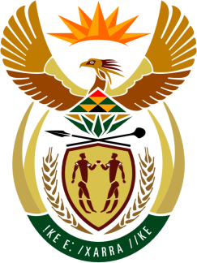

SOUTH AFRICAN PERMANENT MISSION
TO THE UNITED NATIONS
AND OTHER INTERNATIONAL ORGANISATIONS

38th SESSION OF THE WORKING GROUP ON THE
UNIVERSAL PERIODIC REVIEW

Review of denmark

6 may 2021

zoom

(60 Seconds)

speaker no: 41

Check against delivery

Madam President,

South Africa welcomes the distinguished delegation of Denmark to this UPR Session.

South Africa commends Denmark on The Equal Treatment Act, which was amended in 2019, to clarify the scope of sexual harassment. The increase in the compensation for the victims is also noted with appreciation.

South Africa wishes to respectfully make the following recommendations:

- Incorporate the United Nations human rights conventions into national legislation to give full effect to the rights enshrined in the conventions.

- To consider obligations on business enterprises to carry out due diligence to respect human rights and the environment within their global value chains and by their business relationships, to prevent any harm.

- Eliminate the gender wage gap, particularly for women with immigration backgrounds.

South Africa wishes Denmark a successful review.

I thank you

