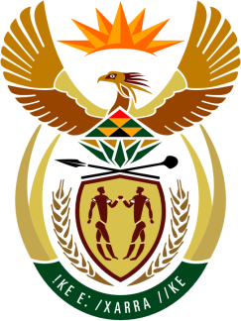

SOUTH AFRICAN PERMANENT MISSION
TO THE UNITED NATIONS
AND OTHER INTERNATIONAL ORGANISATIONS

38th SESSION OF THE WORKING GROUP ON THE
UNIVERSAL PERIODIC REVIEW

4 MAY 2021

PALAIS DES NATIONS

Review oF MOZAMBIQUE

VIRTUAL (ZOOM PLATFORM)
(60 seconds)

Check against delivery

South Africa welcomes Mozambique’s implementation of most of the recommendations of the previous UPR, in spite of the conflict in the Cabo Delgado province and the devastating effects of multiple natural disasters.

South Africa commends Mozambique for its efforts to improve the capacity of human rights institutions, gender parity, and for reforms being undertaken in the justice administration system. We also welcome the steps Mozambique has taken to increase cooperation with UN human rights bodies.

South Africa respectfully recommends that the Mozambican Government:

- Prioritises measures to improve access to quality primary health care, including sexual reproductive health services, to women, children and rural communities.

- Continues to strengthen measures in combating violence against women and girls and fully implement the National Plan to Prevent and Combat Gender-Based Violence.

- Intensifies measures to tackle discrimination and stigma against persons with disabilities and those with albinism.

South Africa wishes Mozambique a successful review.

I thank you.

