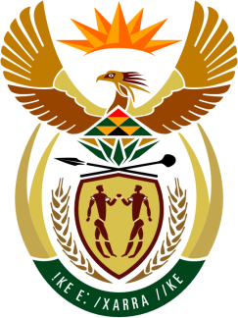

SOUTH AFRICAN PERMANENT MISSION
TO THE UNITED NATIONS
AND OTHER INTERNATIONAL ORGANISATIONS

38th SESSION OF THE WORKING GROUP ON THE
UNIVERSAL PERIODIC REVIEW

Review of NIGER

3 MAY 2021

Zoom

1 min 05 sec

Speaker no. 83

Check against delivery

Madam President,

South Africa welcomes the UPR Report of Niger to this UPR Session.

South Africa commends the Government of Niger for the political reforms that have resulted in its National Human Rights Commission regaining the category A Status.

South Africa wishes to respectfully make the following recommendations to the government of Niger:

- That it considers prioritizing the National Gender-based Violence Prevention and Response Strategy and its five-year action plan for the period 2017–2021.

- That it continues to strengthen actions aimed at combatting trafficking in persons as well as all forms of slavery.

- That it takes measures to strengthen policies and programmes to address the issues of climate change and disaster risk management.

South Africa wishes Niger a successful review.

I thank you.

