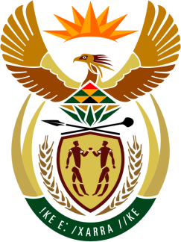

SOUTH AFRICAN PERMANENT MISSION
TO THE UNITED NATIONS
AND OTHER INTERNATIONAL ORGANISATIONS

UNIVERSAL PERIODIC REVIEW

3 MAY 2021

PALAIS DES NATIONS

Review oF NAMIBIA

VIRTUAL (ZOOM PLATFORM)
(60 seconds)

Check against delivery

President,

South Africa welcomes the fraternal delegation of Namibia led by the Honorable Yvonne Dausab, Minister of Justice, to this UPR Session.

My delegation commends Namibia for its targeted policies to address the impact of the COVID-19 pandemic. We also congratulate Namibia for the marked increase in girls and young women graduating notably in Science Technology, Engineering and Mathematics (STEM) fields.

South Africa respectfully recommends that the Namibian government:

- Continues fast-tracking the implementation of its National Plan of Action on Gender-Based Violence 2019-2023, including addressing the root causes thereof.

- Increases its efforts of improving access to health services for rural woman and girls and their communities, as well as for gender and sexual minorities.

- Increases its efforts of tackling stigmatisation and discrimination against persons, especially women and girls, infected with HIV by prioritising support and education.

South Africa wishes Namibia a successful review.

I thank you.

