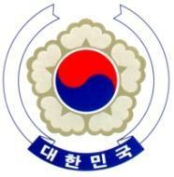

PERMANENT MISSION OF THE REPUBLIC OF KOREA
GENEVA

The 38th Session of the UPR Working Group <Check against delivery>
Review of Somalia
Geneva, 6 May 2021

Statement of the Republic of Korea

Thank you, Madam President.

The Republic of Korea welcomes Somalia to its third cycle of the UPR.

We acknowledge Somalia’s ongoing efforts to improve its human rights situation and welcome its ratification of the Convention on the Rights of Persons with Disabilities.

However, we note with concern reports of grave human rights violations in Somalia, particularly cases of sexual violence in conflict-related situations.

In this regard, we would like to make a few recommendations:

- Step up efforts to combat violence against women and to take a survivor-centered approach, including by strengthening its legal framework in accordance with international standards;

- Further develop measures to achieve a comprehensive nationwide education system, and particularly ensure former child soldiers’ reintegration into society and their access to education; and

- Take further steps to finalize the establishment of the National Human Rights Commission and ensure its full operation in line with the Paris Principles.

We wish Somalia a successful review. I thank you.

/END/

