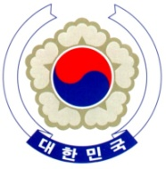

PERMANENT MISSION OF THE REPUBLIC OF KOREA
GENEVA

The 38th Session of the UPR Working Group <Check against delivery>
Review of Singapore
Geneva, 12 May 2021

Statement of the Republic of Korea

Thank you, Madam President.

The Republic of Korea commends Singapore for the positive developments achieved since its last review, notably in the field of safeguarding the rights of migrant workers and persons with disability as well as fostering ethnic and religious diversity.

With such progress in mind, we would like to make the following recommendations:

- Continue its efforts to accede to the core international human rights treaties, mainly ICCPR and ICESCR;

- Ensure that laws and policies on the rights to freedom of expression, peaceful assembly, and association comply with relevant international human rights standards; and

- Move forward in the establishment of an independent national human rights institution in full accordance with the Paris Principle.

We wish Singapore a successful review. I thank you.

/END/

International Covenant on Civil and Political Rights
International Covenant on Economic, Social and Cultural Rights

