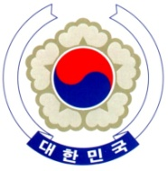

PERMANENT MISSION OF THE REPUBLIC OF KOREA
GENEVA
The 38th Session of the UPR Working Group <Check against delivery>
Review of Mozambique
Geneva, 4 May 2021

Statement of the Republic of Korea

Thank you, Madam President.
The Republic of Korea warmly welcomes the delegation of Mozambique to its third cycle of the UPR.
We acknowledge Mozambique’s ongoing efforts regarding gender issues, especially the increase of women’s political participation in decision-making bodies. We also note Mozambique’s cooperation with UN human rights mechanisms, including its decision to issue a standing invitation to the special procedures of the Human Rights Council.
In a constructive spirit, we would like to present the following recommendations:
- Ratify the International Covenant on Economic, Social and Cultural Rights;
- Ensure that all allegations of human rights violations against civilians, including killing and abduction, are thoroughly and impartially investigated; and
- Redouble efforts to combat discrimination and violence against women and girls, in particular early marriage and domestic violence.
We wish Mozambique a successful review. I thank you.
/END/

