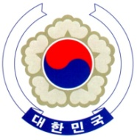

PERMANENT MISSION OF THE REPUBLIC OF KOREA
GENEVA

The 38th Session of the UPR Working Group <Check against delivery>
Review of Belgium
Geneva, 5 May 2021

Statement of the Republic of Korea

Thank you, Madam President.

The Republic of Korea welcomes the positive steps taken by the Belgian government in implementing the recommendations of its last review, including its ratification of the Istanbul Convention. We also commend Belgium for its leading role in driving international initiatives on the protection of the rights of children.

While encouraging Belgium to continue to uphold the highest standards of human rights, we would like to make the following recommendations:

- Continue the ongoing efforts to prevent and tackle intolerance and discrimination on any ground, including by improving data disaggregation;

- Step up the process of establishing a national human rights institution that is fully compliant with the Paris Principles, by ensuring comprehensive human rights mandates and adequate resources; and

- Take additional measures to improve conditions in prisons and detention facilities, including overcrowding issue.

We wish Belgium a successful review. I thank you.
/END/

Council of Europe Convention on Preventing and Combating Violence against Women and Domestic Violence

