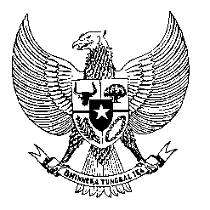

Permanent Mission
of the Republic of Indonesia to the UN, WTO,
and Other International Organizations
in Geneva

STATEMENT BY THE DELEGATION OF THE REPUBLIC OF INDONESIA
AT THE 38th SESSION OF THE UPR WORKING GROUP
CONSIDERATION OF THE UPR REPORT OF NIGER
Geneva, 3 May 2021

Thank you, Madame President,

Indonesia thank the Delegation of Niger for the presentation of their national report.

Indonesia takes note the inclusion of human rights education in schools’ curricula to raise awareness of human rights for the public in general.

For this cycle, Indonesia wishes to offer the following recommendations:

- Continue to Improve health infrastructure including by enhancing international cooperation and increasing qualified medical personnel to enable the necessary provision of health services throughout the country.

- Further protect human rights in combating transnational organized crimes and terrorism.

- Further strengthen the implementation of anti-slavery laws, national action plans to prevent slavery as well as educational measures in eliminating discriminatory practices.

- Enhance institutional and operational capacity of the agencies responsible for preventing and combating trafficking in persons, including with possible bilateral and international human rights training.

We wish the Government of Niger a successful review.

Thank you.

