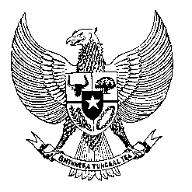

Permanent Mission
of the Republic of Indonesia to the UN, WTO,
and Other International Organizations
in Geneva

STATEMENT BY THE DELEGATION OF THE REPUBLIC OF INDONESIA
AT THE 38th SESSION OF THE UPR WORKING GROUP
CONSIDERATION OF THE UPR REPORT OF SOMALIA
Geneva, 6 May 2021

Thank you, President,

Indonesia thanks the delegation of Somalia for the presentation of its national report.

Indonesia welcomes the progress that Somalia has made since its last review, especially in advancing the rights of persons with disabilities, through the ratification of the CRPD, and the establishment of the National Disability Agency.

To further improve progress in the promotion and protection of human rights in Somalia, Indonesia offers the following recommendations:

- To finalize the establishment of the Somalia National Human Rights Commission, in alignment with the Paris Principles.

- To continue efforts to reform the justice institutions, in particular through the strengthening of law enforcement and judiciary officials.

- To continue efforts in economic recovery and poverty reduction, including through the implementation of its National Social Protection Policy, to address the continuing humanitarian crisis and mitigate vulnerability from natural disasters.

- To ratify the Convention on Migrant Workers

We wish the Government of Somalia a successful review.

Thank you.

