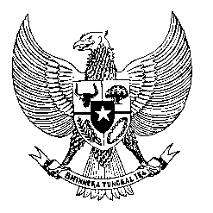

Permanent Mission
of the Republic of Indonesia to the UN, WTO,
and Other International Organizations
in Geneva

STATEMENT BY THE DELEGATION OF THE REPUBLIC OF INDONESIA
AT THE 38th SESSION OF THE UPR WORKING GROUP
CONSIDERATION OF THE UPR REPORT OF SOLOMON ISLANDS
Geneva, 10 May 2021

Thank you Madame President,

Indonesia thanks Solomon Islands for the presentation of its national report.

We take notes the progress that Solomon Islands has made since its last review.

Indonesia remains committed to capacity building and development cooperation with the Solomon Islands, especially in a democracy, human rights advancement, women's empowerment, and child protection;

To further progress in the promotion and protection of human rights in Solomon Islands, Indonesia offers the following recommendations:

First, to ratify as priority, core international human rights instruments including the ICCPR; CAT and the Convention Migrant Workers;

Second, to take further measures to combat corruption, including through cooperation between the Independent Commission Against Corruption with anti-graft agencies in the region,

Third, to strengthen its development policy and the full utilization of resources for the benefit of its people including through friendly relations and collaboration with other States, regional and international organizations.

Fourth, to continue to take concrete steps to establish a national human rights institution in line with the Paris Principles.

We wish Solomon Islands a successful review.

Thank you.

