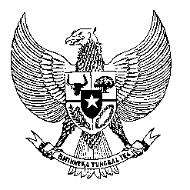

Permanent Mission
of the Republic of Indonesia to the UN, WTO,
and Other International Organizations
in Geneva

STATEMENT BY THE DELEGATION OF THE REPUBLIC OF INDONESIA
AT THE 38th SESSION OF THE UPR WORKING GROUP
CONSIDERATION OF THE UPR REPORT OF SINGAPORE
Geneva, 12 May 2021

Indonesia thanks Singapore for their report.

We appreciate the progress made since its last review, including enactment legislations and policies to improve living standard of its people

We also commend the efficiency and fast response of Singapore in addressing Covid-19, including in protecting the low income, vulnerable residents and migrant workers.

We wish to recommend the following:

First, to ratify ICCPR, CAT and Convention on Migrant workers

Second, to continue supports AICHR (ASEAN Intergovernmental Commission on Human Rights (AICHR) in advancing HRs in the regions

Third, to extend cooperation to address corruption and transnational organized crimes that impacted the enjoyment of human rights

Fourth, to provide a robust faster response for request of consular cooperation and treatment of migrant workers.

We wish Singapore a successful review.

I thank you.

