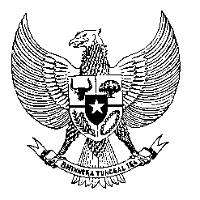

Permanent Mission
of the Republic of Indonesia to the UN, WTO,
and Other International Organizations
in Geneva

STATEMENT BY THE DELEGATION OF THE REPUBLIC OF INDONESIA AT THE 38th SESSION OF THE UPR WORKING GROUP CONSIDERATION OF THE REPORT OF SEYCHELLES
Geneva, 10 May 2021

Thank you, President,

Indonesia welcomes the delegation of Seychelles and thank them for the presentation of their national report.

Indonesia commends the progress made since the last review particularly on the establishment of the National Human Rights Commission and encourage the exercise of its mandate in full compliance with the Paris Principles.

To further strengthen promotion and protection of human rights in the country Indonesia recommends Seychelles to:

- Fulfil human rights obligations based on the international human rights instruments to which it is a party to and ensure their implementation through laws and programs that will strengthen domestic understanding and advance respect for human rights.

- Further mainstream gender perspective into its national policies and programs by providing wider spheres for women’s participation and ensuring gender parity in the development and implementation of those policies and programs.

- Establish adequate legal framework and human rights-based standard for tourism and fisheries industries, paying particular attention to the prevention of human trafficking and forced labour.

- Strengthen national development programs that reach the whole country to meet the 2030 SDGs, including through the utilization of bilateral and international cooperation.

We wish Seychelles a successful review.

Thank you.

