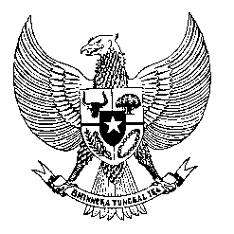

Permanent Mission
of the Republic of Indonesia to the UN, WTO,
and Other International Organizations
in Geneva

STATEMENT BY THE DELEGATION OF THE REPUBLIC OF INDONESIA
AT THE 38th SESSION OF THE UPR WORKING GROUP
CONSIDERATION OF THE UPR REPORT OF PARAGUAY
Geneva, 5 May 2021

Thank you, President,

Indonesia thanks the delegation of Paraguay for the presentation of its national report.

Indonesia welcomes the numerous progress that Paraguay has made since its last review, not least in the strengthening of efforts to combat human trafficking.

To further improve progress in the promotion and protection of human rights in Paraguay, Indonesia offers the following recommendations:

- Continue efforts in aligning its national human rights institution with the Paris Principles.

- Take necessary measures to address prison overcrowding, especially during this time of pandemic.

- Take further steps in strengthening the implementation of Paraguay's Human Rights National Action Plan, especially those related to protecting the rights of women and children.
We wish the Government of Paraguay a successful review.

Thank you.

