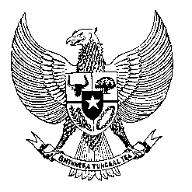

Permanent Mission
of the Republic of Indonesia to the UN, WTO,
and Other International Organizations
in Geneva

STATEMENT BY THE DELEGATION OF THE REPUBLIC OF INDONESIA
AT THE 38th SESSION OF THE UPR WORKING GROUP
CONSIDERATION OF THE UPR REPORT OF PALAU
Geneva, 7 May 2021

Thank you, Madame President,

My Delegation warmly welcome the Delegation of Palau and appreciate the presentation of their national report.

We take note with appreciation the progress made since the second review cycle to promote human rights in Palau including the enactment of legislations to improve school wellness and nutrition standards, social service and care for the aging population and funding for the severely disabled. We encourage the full implementation of these legislation and creation of relevant programs.

We wish to recommend the Government of Palau to:

- Strengthen efforts to develop programs for capacity building and training in the area of education, employment and business to boost economic activities, development and people livelihood including through friendly collaboration with countries, regional and international organizations.

- Mainstream human rights in the development of its public policies and programs and facilitating greater participation of women in the process.

- Continue efforts to ratify International Convention on the Protection of the Rights of All Migrant Workers and Members of their Families as well as other core international human rights instruments.
We wish Palau every success in their review and subsequent implementation of recommendations.
I thank you.

